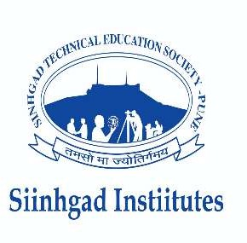


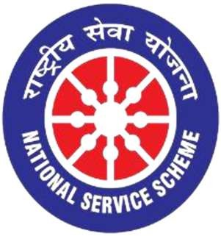
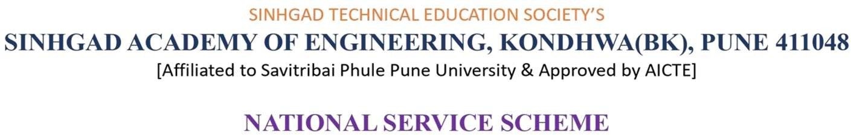



Date: / / 2026

To,
The Principal
Sinhgad Academy of Engineering
Kondhwa, Pune
Subject: Permission for conducting Chhatrapati Sambhaji Maharaj Jayanti Program
Respected Sir,
Date of Event: 14 May 2026
On behalf of the NSS unit of Sinhgad Academy of Engineering, I request your permission to celebrate Chhatrapati Sambhaji Maharaj Jayanti in the college premises near the Admin Office.
The event will include a tribute and short speeches to spread awareness about his life and contributions. It will be conducted in a disciplined manner under the guidance of NSS coordinators without disturbing regular academic activities.
Kindly grant us permission for the same.
Thanking you.
Yours sincerely,
NSS Programme Officer

